DC Motor Speed Control Using Arduino

Description:
The DC Motor Speed Control project is used to control the rotational speed of a DC motor using a potentiometer.
In this project, a B10k potentiometer provides variable input to the Arduino, which generates a PWM signal.
The L298 motor driver is used to interface the low-power Arduino with the high-current DC motor.
A battery supply is used to power the motor, making the system suitable for basic motor control applications.
Block Diagram:
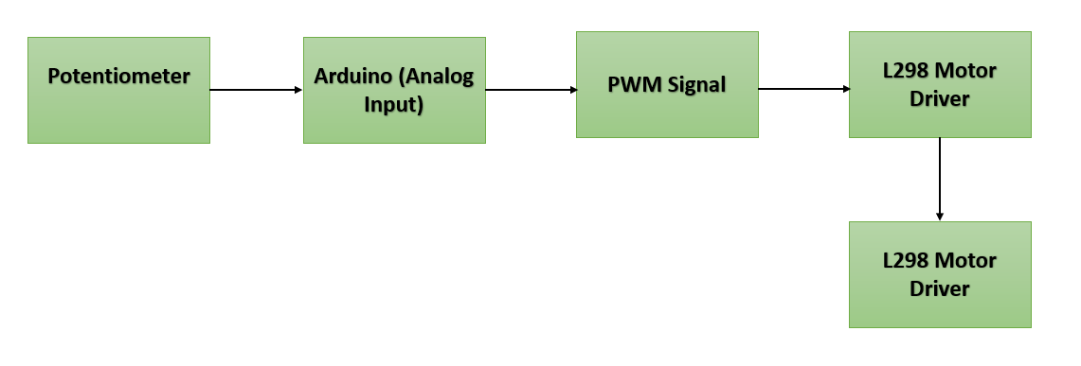

Pinout / Circuit Connection:
- Potentiometer Middle Pin → Arduino A0
- Potentiometer Side Pin 1 → Arduino 5V
- Potentiometer Side Pin 2 → Arduino GND
- Arduino D9 (PWM) → L298 ENA
- Arduino D8 → L298 IN1
- Arduino D7 → L298 IN2
- L298 OUT1 & OUT2 → DC Motor Terminals
- L298 Motor Supply (Vs) → 6 × AA Battery Pack (+)
- L298 GND → Battery (–) and Arduino GND (Common Ground)

Components Required:
- Arduino Uno
- DC Motor
- L298 Motor Driver Module
- B10k Potentiometer
- 6 × 1.5V AA Batteries
- Battery Holder
- Jumper Wires
- Breadboard

Working Principle:
The potentiometer acts as a variable voltage divider.
Arduino reads the analog voltage and converts it into a digital value.
Based on this value, Arduino generates a PWM signal at the ENA pin of the L298 driver.
The L298 controls the power supplied to the DC motor, thereby controlling its speed.
Changing the potentiometer position varies the motor speed smoothly.
Operation (Step-by-Step):
• Connect the potentiometer, Arduino, L298, and motor as per the circuit
• Insert AA batteries into the holder
• Upload the motor speed control program
• Power ON the Arduino and motor supply
• Rotate the potentiometer knob
• Motor speed increases or decreases accordingly

Arduino Code:
#define POT_PIN A0
#define ENA 9
#define IN1 8
#define IN2 7

void setup() {
pinMode(ENA, OUTPUT);
pinMode(IN1, OUTPUT);
pinMode(IN2, OUTPUT);

digitalWrite(IN1, HIGH);
digitalWrite(IN2, LOW); // Motor direction fixed
}

void loop() {
int potValue = analogRead(POT_PIN);
int motorSpeed = map(potValue, 0, 1023, 0, 255);

analogWrite(ENA, motorSpeed);
delay(10);
}

Conclusion: (Predefined/self-written)
The DC Motor Speed Control project demonstrates effective control of motor speed using PWM and a motor driver.
It helps students understand motor interfacing, driver circuits, and analog-to-digital conversion.
This project can be extended for bidirectional control, automation, or robotics applications.
For Your References:
[1] M. Margolis, Arduino Cookbook, 2nd ed. Sebastopol, CA, USA: O’Reilly Media, 2011.
[2] Arduino, “PWM – Analog Write,” Arduino.cc. [Online]. Available: https://www.arduino.cc/en/Tutorial/PWM. [Accessed: Apr. 10, 2016].
[3] Texas Instruments, “L298 Dual Full-Bridge Driver Datasheet,” 2014.

